For sending mail from website hosted in godaddy

Login and come to cpanel screen

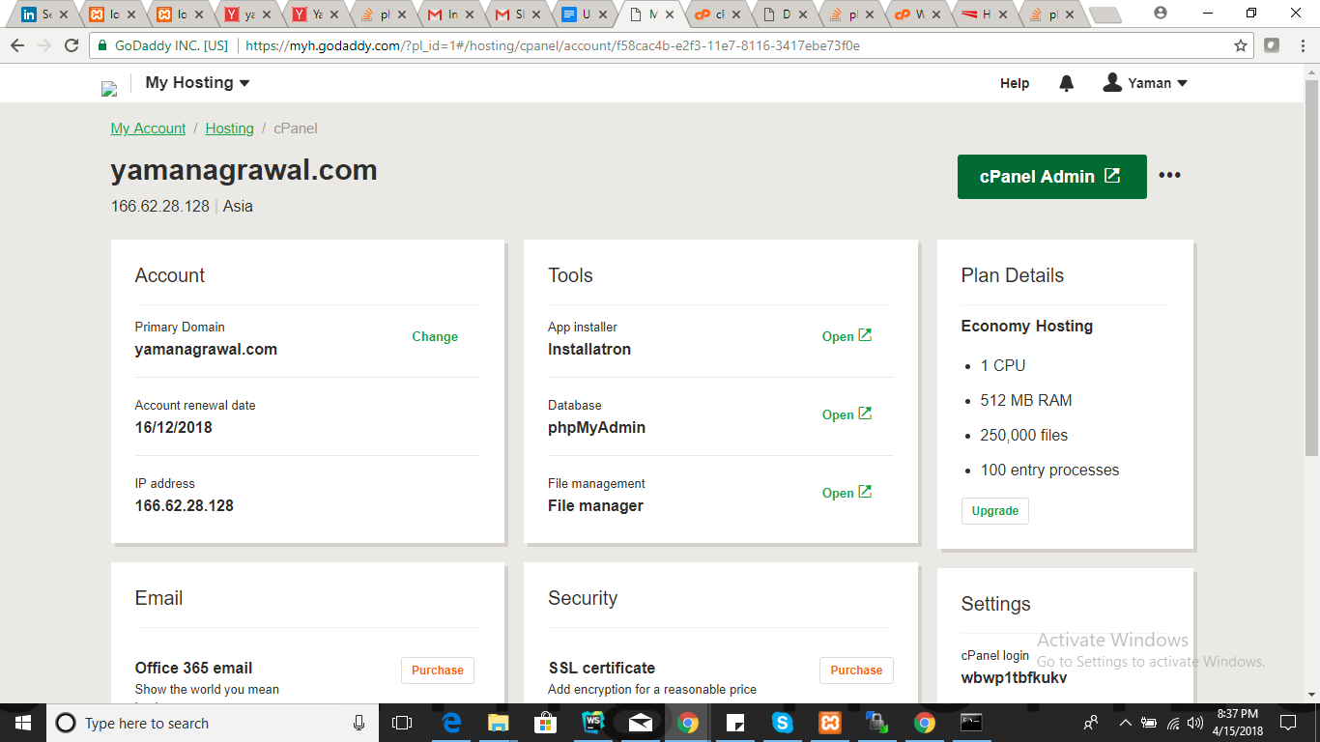

Click on “cpanel admin”

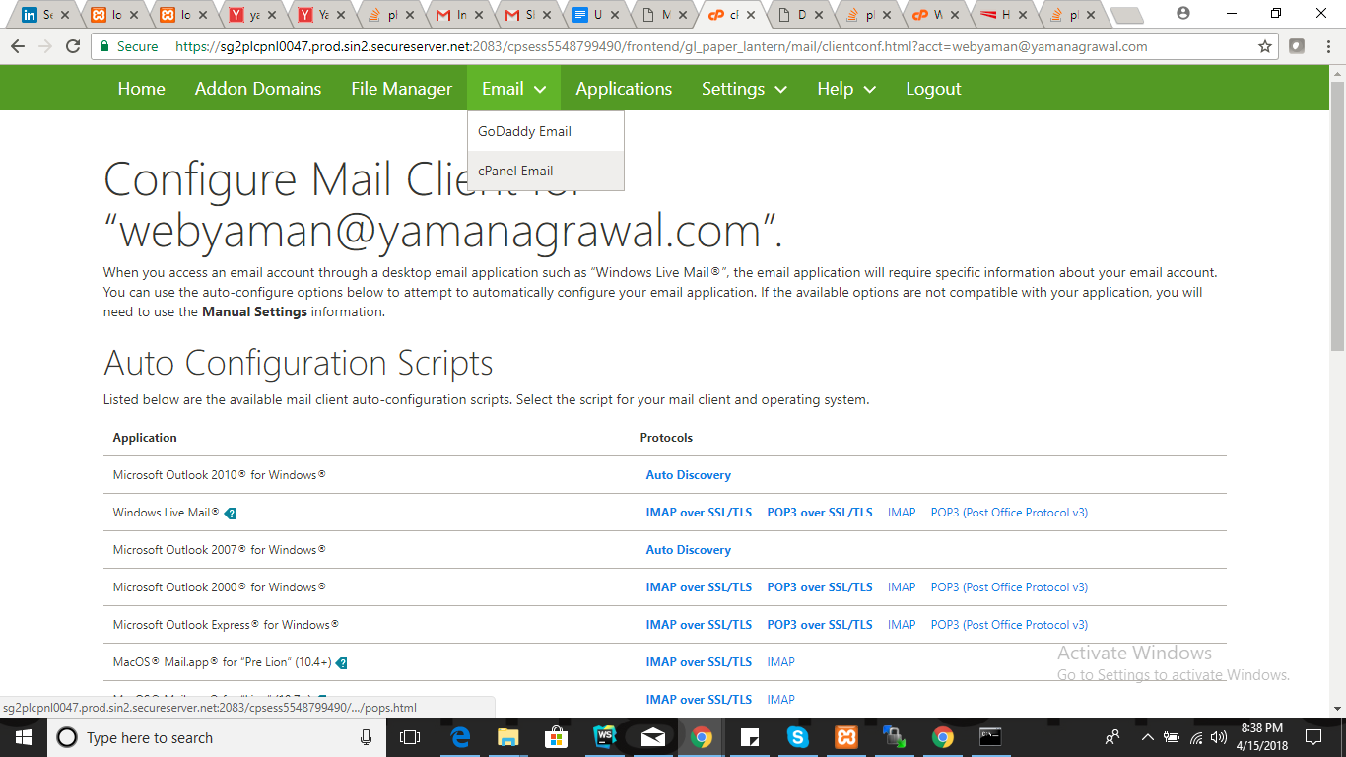

Click “Email -- > Cpanel Email”

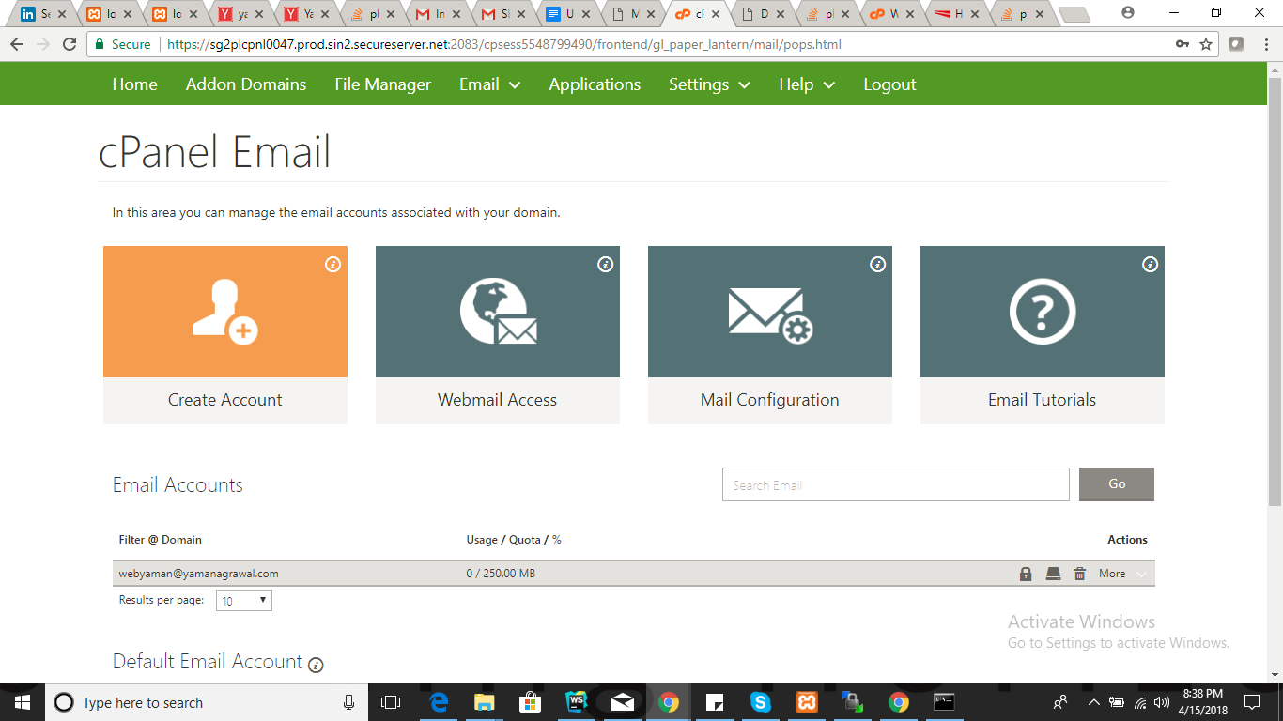Click “Create Account” and create a cpanel email account.

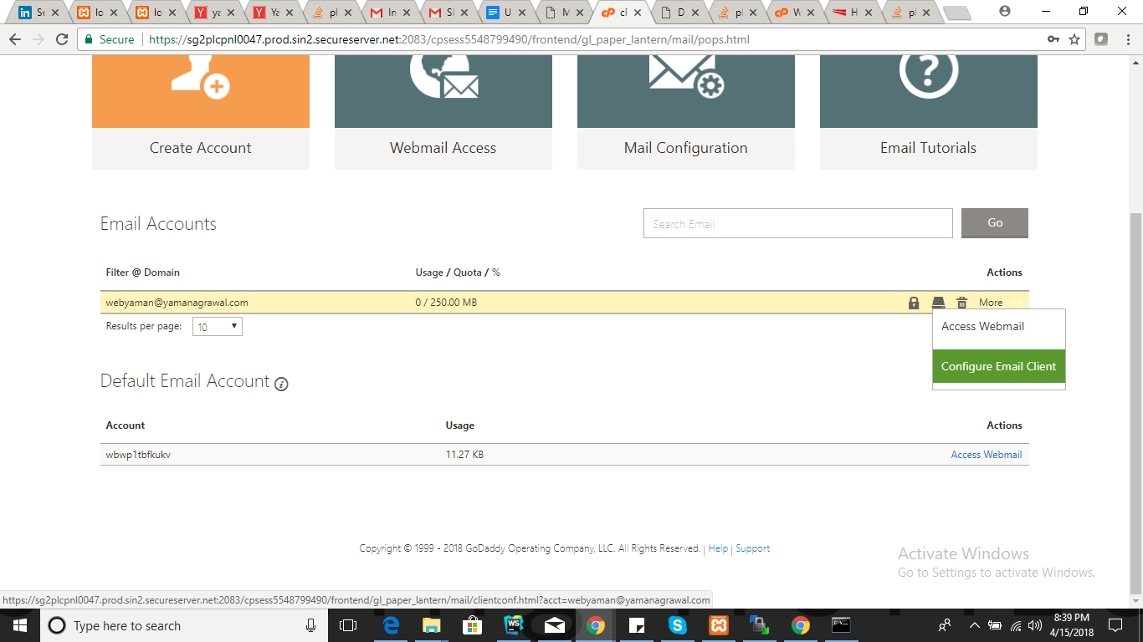Click “Configure Email account”

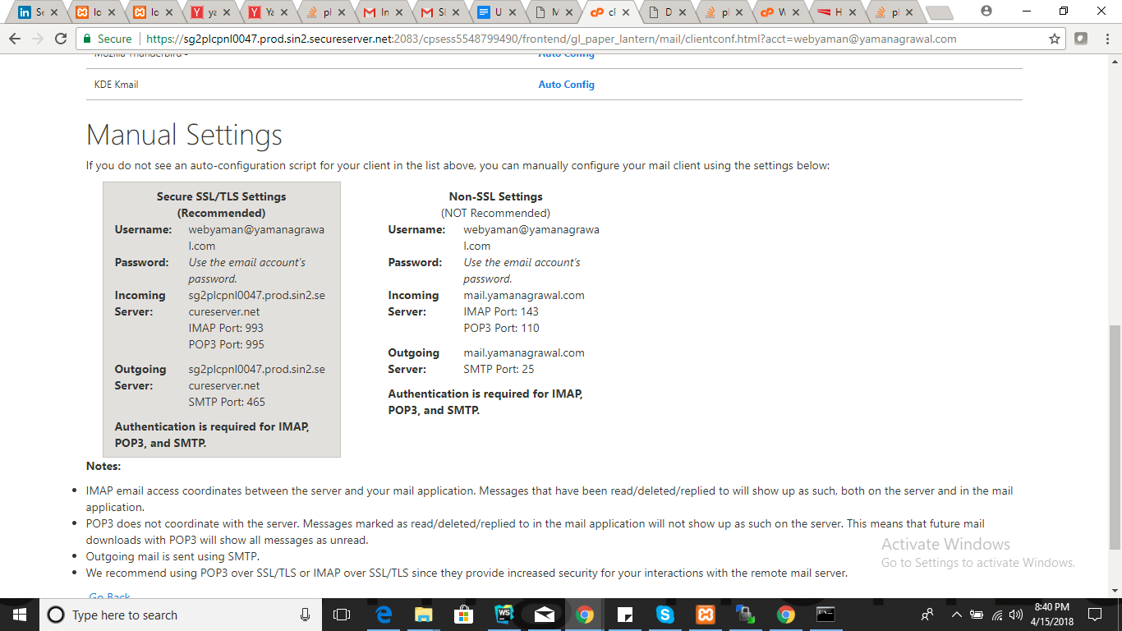

Use manual settings

Example : using phpmailer

<?php

include 'scripts/PHPMailer-master/src/Exception.php';

include 'scripts/PHPMailer-master/src/PHPMailer.php';

include 'scripts/PHPMailer-master/src/SMTP.php';

$message = 'Name: ' . $_POST['FIRST_NAME'] . $_POST['LAST_NAME'] . "\r\n\r\n";

$message .= 'Email: ' .$_POST['EMAIL'] . "\r\n\r\n";

$message .= 'Mobile Number: ' .$_POST['MOBILE_NUMBER'] . "\r\n\r\n";

$message .= 'Message: ' .$_POST['MESSAGE'];

$mail = new PHPMailer\PHPMailer\PHPMailer();

$mail-> IsSMTP(); // enable SMTP

$mail-> SMTPDebug = 1; // debugging: 1 = errors and messages, 2 = messages only

$mail-> SMTPAuth = 'true'; // authentication enabled

$mail-> SMTPSecure = 'ssl'; // secure transfer enabled REQUIRED for Gmail

$mail-> Host = 'sg2plcpnl0047.prod.sin2.secureserver.net'; //SMTP server address, use 'smtp.gmail.com' for gmail

$mail-> Username = 'webyaman@yamanagrawal.com'; //It is your cpanel/gmail email address

$mail-> Password = 'India@1234';

$mail-> Port = 465; //465 for SMTPSecure = ssl

$mail-> SetFrom('webyaman@yamanagrawal.com','Yaman Website');

$mail-> addAddress('yaman.a@msystechnologies.com','Yaman'); //Recipient address

$mail-> addReplyTo('webyaman@yamanagrawal.com','Yaman');

$mail-> isHTML(true);

$mail-> Subject = 'Sbm Goldoyl - Contact Us';

$mail-> Body = "

<html>

<h2><b>".$message." ".$message.", ".$message."</b></h2>

</html>";

if (!$mail->send()) {

echo "Mailer Error: " . $mail->ErrorInfo;

} else {

echo "Message sent!";

}

?>

Contactus.html

<form name="contact-form" id="contact-form" method="POST" action="send_mail.php">

<div class="form-group col-sm-6">

<label for="fname">First Name*</label>

<input type="text" name="FIRST_NAME" class="form-control require-field" id="fname">

<small class="error-message remove">Please enter your First Name</small>

</div>

<div class="form-group col-sm-6">

<label for="lname">Last Name*</label>

<input type="text" name="LAST_NAME" class="form-control require-field" id="lname">

<small class="error-message remove">Please enter your Last Name</small>

</div>

<div class="m-top-40 form-group col-sm-6">

<label for="emailAddress">Email Address*</label>

<input type="text" name="EMAIL" class="form-control require-field" id="emailAddress">

<small class="error-message remove">Please enter your Email address</small>

</div>

<div id="mobile-number" class="m-top-40 form-group col-sm-6">

<label for="mob">Mobile Number*</label>

<div class="my-group">

<input type="text" name="MOBILE_NUMBER" class="form-control require-field" placeholder="" id="mob">

<small class="error-message remove">Please enter your phone number</small>

</div>

</div>

<div id="sub-cntr" class="col-sm-12"></div>

<div class="form-group col-sm-12">

<label for="message">Message*</label>

<textarea name="MESSAGE" class="form-control require-field" rows="5" id="message"></textarea>

<small class="error-message remove">Please enter your message</small>

</div>

<div class="m-top-40 form-group col-sm-12">

<input type="submit" name="SEND" value="Request Callback">

<button type="reset" class="btn btn-default reset-btn">Reset</button>

</div>

</form>

Important Links :

<https://stackoverflow.com/questions/21937586/phpmailer-smtp-error-password-command-failed-when-send-mail-from-my-server>

<https://stackoverflow.com/questions/21841834/phpmailer-godaddy-server-smtp-connection-refused>

<https://stackoverflow.com/questions/34076023/inserting-html-post-form-field-data-into-phpmailer-email-body>